WHAT HAPPENS TO DEAD PLANTS AND ANIMALS?

Decomposition

ELEMENTARY SCHOOL UNIT

TEACHER GUIDE

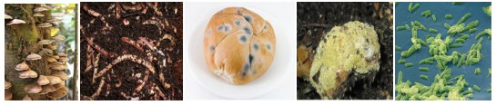

March 2009

Michigan State University

Environmental Literacy Project

Lindsey Mohan, Ed Smith, and Andy Anderson

Table of Contents
Table of Contents 2
Unit overview and background……………………………………………..………………………………………3
Embedded Assessments 6
Materials List…………………………………………………………………………………………………………….………7
activity 1: exploring ecosystems……………………………………………………………….………………….8
Activity 2: What happens to dead plant and animal materials? 16
Activity 3: Observing Mold on Pumpkins 19
Activity 4: Bananas and Yeast- (Setting-Up the Experiment) 24
Activity 4: Bananas and Yeast- Observations and Discussion 27
Activity 5: Adding ‘Decomposers’ to the Ecosystem Chart * 30
Activity 6: Matter and Energy in Ecosystems 34

Resources:
Hogan (1994). Eco-Inquiry: A Guide to Ecological Learning Experiences in Upper
Elementary/Middle Grades. Dubuque, IA: Kendall/Hunt Publishing.
SCIIS (Lawson, Knott, Karplus, Their, Montgomery (1978) SCIIS Communities and
SCIIS Ecosystems Teacher’s Guides. Chicago: Rand-McNally.
North Cascades & Olympic Science Partnership. (2007). Matter and Energy in Living
Systems
Unit Overview and Background

Our work on the Environmental Science Literacy Project has been to document the accounts students have for events that occur in natural and human social systems. At the macroscopic scale we documented students’ accounts of growth, weight loss, decay and burning and at the large scale we looked at their accounts of global warming and deforestation. The goal of our work has been to develop a learning progression that describes how accounts of changes in matter and energy develop from grades 4-12. One important conclusion from this work, and our experiences in classrooms, is the following: When students enter school they use narratives (or stories) to explain how the world works. This is the students’ natural discourse. The information they learn in science class teaches them more detailed narratives and new vocabulary, and students try to fit the new information into their existing narratives. Thus, students tell the same stories with more details, instead of learning new, more principled accounts about their world.

Our carbon cycle learning progression describes what we observed from students at different levels (and different age groups). We used this information to design classroom materials that support (productive) progress toward building new accounts about the world—specifically to build principled accounts about carbon cycling.

The carbon cycle learning progression levels: Our learning progression is comprised of four Levels of Achievement:
- Level 1 students (at the lower anchor of the learning progression) use force-dynamic reasoning (Pinker, 2007; Talmy, 1988) in which actors (e.g., animals, plants, flames) use enablers (e.g., air, water, food, fuel, sunlight) to fulfill their natural tendencies. Events result from the interplay between the natural tendencies of agents and the balance of forces between enablers that support actors in fulfilling their capacities, and antagonists, which can prevent this from happening.
- At level 2 students are still guided by force-dynamic reasoning, but can point to hidden mechanisms that move beyond natural tendencies and begin to recognize the need to trace materials in and out of systems. Gases are treated more like conditions as opposed to “real matter” and matter and energy are not distinguished.
- At level 3 students begin to recognize chemical changes at a cellular and atomic-molecular level and use chemical identities for several important substances. Some level 3 students attempt to conserve both matter and energy without necessarily knowing great detail about chemical substances and processes. However, some level 3 students also may have difficulty with consistently applying conservation principles (i.e., convert matter and energy; ignore gases).
- At level 4 students see events as “chemically” similar or different and can reason about events in terms of chemical substances and processes. They can also fluidly move between different scales in their reasoning.

In general, most elementary school students give level 1 (42%) and 2 (39%) accounts on our assessments. Only 6% of students give level 3 accounts. Therefore, an important goal for elementary school students would be to get more students to consistently use level 2 and 3 reasoning. This involves supporting students in recognizing and using important principles to guide their reasoning and to move beyond the visible, macroscopic scale. In particular, this unit helps students use SCALE, MATTER, and ENERGY principles and introduces students to several tools that support reasoning with these principles.

The overview below describes the progression of activities in the unit. Students will focus on two key processes during this unit: Decomposition and Food Chains. Importantly, they will use the process tool to describe what happens to matter and energy at the cellular and macroscopic scales.

Number | Activity Title | Topic | Time
1 | Exploring Ecosystems | This lesson serves as a review of what students know about plants and animals and food chains. Students use cut-out images of plants and animals and arrange the images into food chains and webs. They place their food chains/webs onto a community chart and identify groups of producers, primary consumers (herbivores) and secondary consumer (carnivores) in terms of their sources of food and energy. Student will add arrows to represent the flow of food through the food webs. Community chart and labels to represent light, water, air (carbon dioxide, oxygen). They will use arrows to show how energy originally from the sun and matter (water, food, air) flow through the ecosystem. Later in the module students will add decomposers to the chart. | 50 minutes
2 | What Happens to Dead Plants and Animals? | This lesson establishes a problem for students to think about, What happens to dead plants and animals in ecosystems?, and elicits students’ initial ideas about decomposition. Students will record their initial ideas and discuss these with the class. The teacher will also record students’ questions about decomposition and how this happens. Students also watch a powerpoint that zooms into a compost pile. | 60 minutes
3 | Observing mold on pumpkins  (Note that pumpkins need to be started ahead of time) | In groups, students observe a bag of moldy pumpkin and make observations of the mold and pumpkin using hand lenses. They record the initial mass of the pumpkin before the investigation and the end mass. In small groups or pairs, students discuss reflection questions and share their ideas with the whole group. The purpose of this activity is to allow students to make careful observations of one type of decomposers and think about what happens to the mass of the pumpkin as it decomposes. Students complete a process tool to show both decomposer growth and cell respiration. | 40-50 minutes
4 | Observing yeast on bananas  (Note that part 1 is setting up experiment and should be completed ahead of time) | Students set-up and make observations their yeast investigations. They record their observations and share these with the whole group. The purpose of this lesson is to provide students with experience with another type of decomposers and prompt students to think about conditions that support decomposer growth, especially temperature. | Part 1: Setting up: 35 minutes  Part 2: Observations 35 Minutes
5 | Decomposers and the Community Chart | At this point students revisit the community chart developed during the Exploring Ecosystems lessons. It is time for the students to add decomposers to the community. Students will use cut-out images of decomposers and place these on the community chart. The teacher directs students to think about what would happen to ecosystems without decomposers and why are decomposers so important. Students also consider how decomposers are alike or different from plants and animals? | 60 minutes
6 | Matter and Energy in an Ecosystem | Now that the ecosystem chart includes decomposers, the students construct simple food chains and use the process tool to show how materials and energy move in the food chains. They then revisit the Ecosystem chart making sure they have accounted for al the types of matter and energy that move in ecosystems. | 60 minutes

Embedded Assessments

Make copies for Environmental Literacy Project (for focus students only). Page numbers from teacher guide.

- Exploring Ecosystems (pages 11-12)

- What happens to Dead Plants and Animals? (page 18)

- Observations of Mold (page 21-22)

- Bananas and Yeast (page 26)

- Observing Bananas and Yeast (pages 28-29)

- What Do Food Chains Tell Us? (pages 36-38)
Materials List

Teacher Materials
Computer and/or overhead/opaque projector
5 colors of permanent markers
Ecosystem Chart on butcher/white paper (large enough for class activities)
Chart or transparency for the ‘Big Question’ to record student ideas
Overheads to record students’ observations across the whole class experiments
Chart or transparency with the Big Question for constructing the class answer
Chart or transparency for the question, “What would happen if there were no decomposers?”
How Decomposers Work transparency
Comparing Organisms transparency
Compost powerpoint
Digital balance

Materials for Student Groups (non-labs)
Organism cards- Lesson 1
Decomposer cards- Lesson 5

Materials for Student Groups (labs)
1 bag of pumpkins/squash with holes for ventilation
Hand lenses
4 small pieces of banana
4 small vials with caps OR Petri dishes
1 packet of yeast
Optional: tweezers for placing bananas in the vials

Student Handouts
Exploring Ecosystems
What happens to Dead Plants and Animals?
Observations of Mold
Bananas and Yeast
Observing Bananas and Yeast
What Do Food Chains Tell Us?
Activity 1: Exploring Ecosystems

Overview
Whole Group: Identify living things and how they interact 10 minutes
Small groups: Identify food chains 10 minutes
Whole group: Construct an ecosystem chart 10 minutes
Whole group: Describe energy and matter flow 10 minutes
Initial Ideas 10 minutes

Total Estimated time: 50 minutes

Purpose
The purpose of this activity is to introduce students to food chains and ecosystems. Student first list organisms they know of in ecosystems. They construct simple food chains between those organisms (mainly plants and animals). They are reminded of the types of materials that plants and animals need to grow and how they get energy. They label materials and energy moving between organisms on a food diagram.

Materials
Copies of Exploring Ecosystems
Organism cards
Ecosystem chart
Colored markers (black plus two other colors for energy and matter)

Advance Preparation
Make copies of Exploring Ecosystems if not provided by MSU
Cut out organism cards (if not completed by MSU)
Draw Ecosystem chart on board (if a poster is not provided by MSU)

Procedures

- Introduce the example ecosystem using a poster, video, book or other means (if you have an ecosystem in mind, such as a forest area surrounding school). This should be a forest ecosystem. Start by identifying the living things they see or infer might be present. Discuss how the living things interact. Most students will likely know that some things “eat” other things. As the eating relationships are brought out, suggest diagramming the food chains.
- Provide a set of picture cards of forest organisms to small groups. They should construct several different complete food chains. The food chains can be recorded with the organisms’ names after they are constructed so that the students can reuse the pictures in constructing new food chains. Have students record their ideas on the Exploring Ecosystems handout.
- Have the students report their food chains. Record them on a chart. The pattern that each food chain begins with plants can be developed. This can be the basis for setting up an ecosystem chart (like SCIIS), as shown below, with plants in the bottom box, first level animals in the second, and higher level animals in the top box.

The reason for the pattern of plants beginning every food chain can then be considered and the idea developed that the plants are the living things that can use light as a source of energy while other living things need to take in food as their energy source. A label with ‘light’ can be added to the chart with arrows to the plants box. Labels for “food’ can be added over the arrows leading from the plants to the first level animals and from the first to the second level animals. The terms ‘producer,’ and ‘consumer’ may be familiar to the students. If not, these terms should be introduced with a brief explanation. Plants PRODUCE their own food using light as an energy source. Animals CONSUME plants or other animals as their energy source. Cards with ‘producers’ and ‘consumers’ can be added to the chart.
Later, when the cart is revisited toward the end of this unit, a fourth box can be added to the diagram as shown at the right. Leave room for this box as the diagram is developed.

- Point out that the chart shows how the living things get the energy they need. Remind students that living things get energy from the food they eat, so the arrows in food chains represent food (energy-rich matter) and the chemical energy found in food going between living things. The energy flow in ecosystems can be represented by using a colored marker to trace arrows from the ‘light’ label to the producers box and on to the two levels of consumers. Add key identifying colors representing ‘Energy Flow in an Ecosystem.’ – See following page for suggestions for colors
- Ask if the living things need matter as well as energy. How does matter flow through the ecosystem? Remind students that Producers (plants) take in carbon dioxide and water that they convert into sugar. They also take in minerals that they use in building sugars into other living (organic) materials that make up their bodies. These are the materials required as the plants grow.
  - Animals need matter to make their bodies out of too. They must get that matter in the form of food and air they take in. They can use plants or other animals as food to get the materials they need to grow.
  - Use a different color maker to color the arrows from water & carbon dioxide and minerals to plants and then another color that shows food being made by plants and going from plants to animals in the form of “Food (organic carbon in organisms)”. In the key identify that color as representing matter flow in the ecosystem.

Ecosystem Chart Color Key

Materials/Matter

Food (organic carbon in organisms)

Carbon dioxide and water

Energy

Light Energy

Chemical Energy

Heat

Note: You can use a separate color for motion energy if needed.
Name: __________________________________________ Date: _____________

Exploring Ecosystems

Scientists study living organisms in ecosystems by constructing food chains and food webs. Food chains show how different living things are connected to one another.

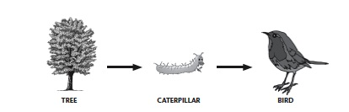
Here is an example of a food chain:

This food chain tells you that the caterpillar eats part of the tree, and that the bird eats the caterpillar. But this is not all that food chains can tell you!

Your teacher will give you a set of cards with images of different plants and animals. Working with your group, try to construct different food chains using the cards. You will need to think about what the organism eats in order to decide where the organism fits in the food chain. Record your food chains below, like the example in row 1.

Possible Food Chains:
# | List food Chain Here
1 | Tree → Caterpillar → Bird
2

3

4

5

6

7

Initial Ideas about Ecosystems
- What does a food chains tell you? What is represented by the arrows? ___________
________________________________________________________________________________________________________________________________________________________________________________________________________________________________________________________________________________________

2. Animals that eat producers are called “primary consumers” or “herbivores”. Animals that eat primary consumers are called “secondary consumers” or “carnivores”. Look at the chart your class constructed. List the different type of animals in the table below.

Producers | Herbivores | Carnivores

3. Do you think anything is missing from your ecosystem chart? ___________________
__________________________________________________________________________________________________________________________________________________________________________________________________________________

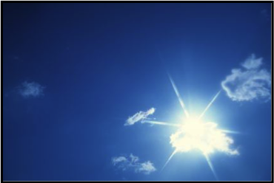
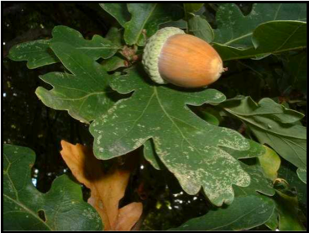
SUNLIGHT
ACORN/OAK TREE

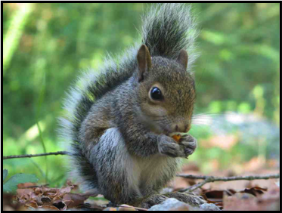
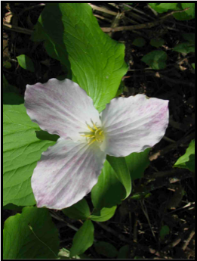
SQUIRREL
FLOWERS

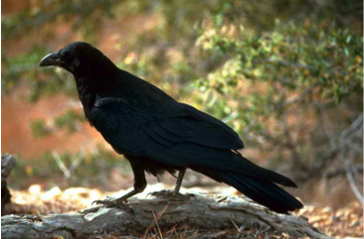
RAVEN (BIRD)
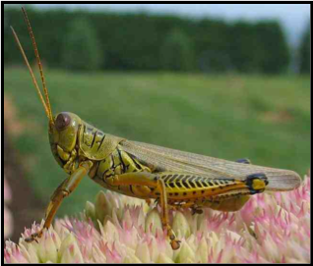
GRASSHOPPER

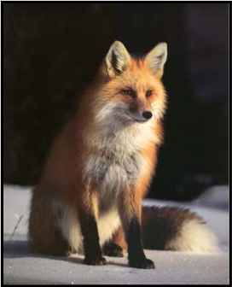
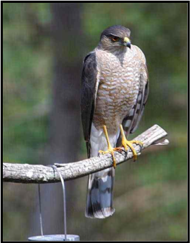
FOX
HAWK

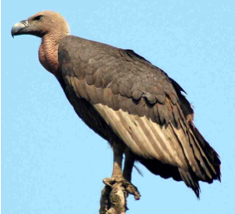
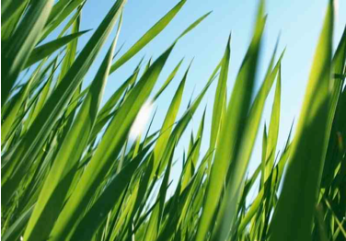
VULTURE
GRASS

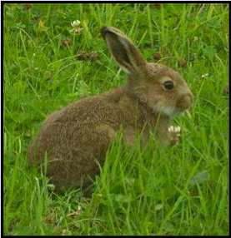
RABBIT

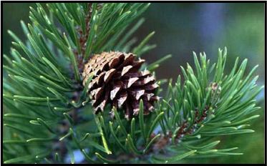
PINE CONE/TREE

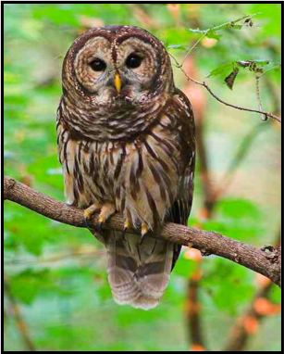
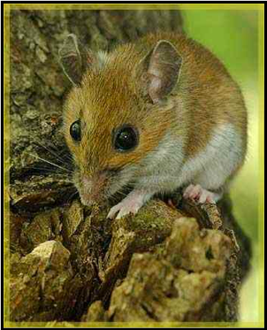
OWL
MOUSE
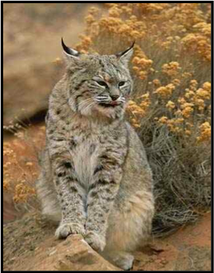
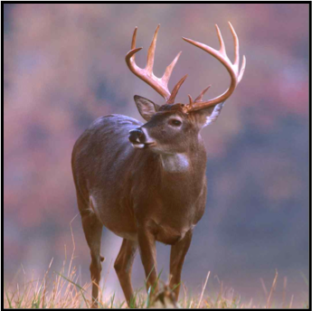
BOBCAT
DEER

Activity 2: What happens to dead plant and animal materials?

Overview
Review Initial Ideas on Exploring Ecosystems 15 minutes
Big Question Whole Class 5 minutes
Individual writing to question 10 minutes
Whole class discussion 15 minutes
Power point: compost.ppt 10 minutes

Total Estimated time: 60 minutes

Purpose
The purpose is to have students think about where “matter” or materials go once they are dead. Students know that leaves off trees do not pile up year after year, but where do they go. The students share their initial ideas to this question and brainstorm how these materials change over time.

Materials
Ecosystem chart
Marker
Student copies of What happens to Dead Plants and Animals?
Chart or transparency for the ‘Big Question’ to record student ideas

Procedures

- Hang up the ecosystem chart from yesterday. Ask students what they remember about the matter and energy arrows that were added to the chart. Students will obviously think the arrows represent “food”, but they might not associate this with the flow of energy-rich matter, for the sake of obtaining chemical energy. Try to make connections to the definition of food as an energy-rich material. You will also want to review the new terminology with students: herbivore, carnivore, consumer and producer.
- Referring to the ecosystem and organisms from Activity 1 and to the ecosystem chart, tell students that they are missing a big piece in the ecosystem and before they continue to learn about food chains they need to add another type of organism to the chart. Describe the accumulation of leaves, fallen trees, animal waste and dead animals that would occur on the forest floor. Ask if any of them have walked in a forest or woods, perhaps in a nearby park. Did they see big piles of dead leaves and animal waste everywhere (Not just some recently fallen, but layers from many years getting deeper and deeper)? What happens to fallen leaves and trees and to animal waste and dead animals that are not immediately eaten by predators? Write this ‘Big Question’ on a chart or overhead transparency so that it can used throughout the unit.
- Big Question: What happens to dead plant and animal material?
- Pass out student handouts and have students write down their initial ideas to this question. Encourage them to write sentences. They may want to draw to help them express their ideas.
- Post an overhead with a statement of the question. Add the label “Initial Ideas” under the question. Have the students share their ideas.
The initial responses are likely to be short (They rot, blow away, break up, get eaten, etc.) Encourage the students to give more complete descriptions, say what they mean by ‘rot,’ etc.) Their ideas are likely to include rotting, going into the soil, breaking up, disappearing. Point out that these answers do not indicate how these things happen.
- How does this happen?
Explore their ideas about how or why these things happen. Add this question and list their ideas on the chart.
Some students may already be very familiar with decomposers, so probe what they know about these organisms. What are they? Where do they live? What do they do with the dead plant and animal material?

Powerpoint
Use the compost.ppt to zoom into a compost pile. This powerpoint will start at the macroscopic scale and step down to the microscopic scale to show different kinds of decomposers found in compost piles.

Name:_____________________________________ Date: ____________

What Happens to Dead Plants and Animals?

In the Fall, many leaves fall of the trees and pile up on the ground. Most of these leaves are gone by summer. What happens to the materials that make up the leaves?

Now that your class has talk about your ideas, do you have anything new or different to add to what you wrote above?

Activity 3: Observing Mold on Pumpkins

Overview
Pair/groups observations 20 minutes
Process Tool 20 minutes
How Decomposer Work (optional) 10 minutes

Total Estimated Time: 40-50 minutes

Purpose
Students will make observations of mold growing and begin to think about mold, and other decomposers as living organisms that need food and air to survive. The growth of mold shows that mold ‘grows’, but since students record mass at the start and finish they will find that overall mass decreases. This give the teacher a chance to make the point that some food/pumpkin becomes part of the mold, but some of the matter is going somewhere else. Students use the process tool to think about decomposer growth and decomposer use/respiration.

Materials
Student copies of Observations of Mold
1 bag of moldy pumpkins/squash for each pair/group
Hand lenses for each student
Digital balance

NOTE: Students must record their mass prior to molding so that they can take an end mass.

Advance Prep
Start the pumpkin squash at least 1 week in advance; and have students record their start mass at that time.

Procedures

Setting Up:

Give student groups/pairs a bag of pumpkin pieces or squash. Make sure the bags have tiny holes for ventilation. Have each group record their start mass on their handout.

Results and Conclusions:

Pass out observation sheets and hand lenses, and make sure the digital balance is ready for use.

- Have groups collect their bags. As each group comes up to find their “End Mass”, have the remaining students make descriptive observations.

- After students have completed their observations, have them share their end mass with the whole group. Pool the data and help students see the pattern that the bags lost mass overtime.

- The teacher might explain to students the part of the mold that absorbs food: “The mold you’ve described in a kind of fungus. The white fuzz you see is called hyphae. The hyphae absorb food.” Point out to students that the mold organism is growing. Ask them where the mold is getter the matter to grow? Use the process tool to show organism growth: Chemical energy in the pumpkin becomes chemical energy in the mold; the body structure of the pumpkin becomes the structure of the mold.

- Then point out that overall the bags lost mass. Where do they think that mass went? The mass of the pumpkin decreases and the amount of mold increases, but these were not equal. Some of the material from the pumpkin was going somewhere else. Use the process tool to show that the pumpkin/food (and oxygen) turns to carbon dioxide and water; and that the mold cells get chemical energy in food and change it to motion energy and heat.

- Have students complete the combined process tool diagram on their handout to show that mold uses some of the pumpkin to grow and it becomes part of the mold, but that mold also gives off gases.

Note: The overhead transparency How Decomposers Work can be used to read about decomposition. This is an optional resource.
Name:_____________________________________ Date: ____________

Observations of Mold

Mass Observations:

Start Mass: ____________
End Mass: _____________
Difference: _____________

Descriptive Observations:

Describe and draw as completely as possible what you see happening to the pumpkin.

Describe and draw as completely as possible what you see happening to the mold.

QUESTIONS:

- The mold uses the pumpkin material for two things. Use the process tool to show what two things may happen to the matter and energy as the mold eats the pumpkin.
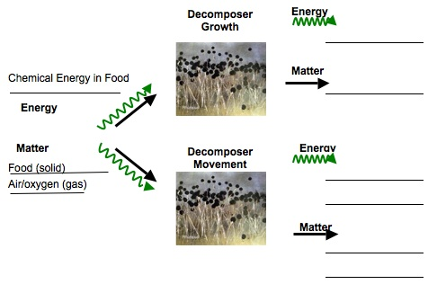

2. If someone said the stuff that makes up the pumpkin eventually turns into gases in the air, would you agree? Why or why not? ___________________________________
__________________________________________________________________________________________________________________________________________________________________________________________________________________
How Decomposers Work

You’ve learned a lot about decomposers. You’ve learned that they grow on things, like pumpkins and bananas. You’ve learned that they eat the dead plants and animals in an ecosystem. Today you will think about how decomposers are alike and different from plants and animals in the way they get and use food.

First, think about what is “food” for decomposers. What is the energy-supplying source of food that they need to live?
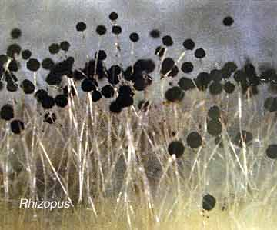
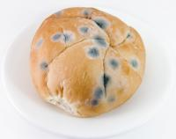

The photographs above show mold that you see with your eyes, and what that mold looks like under a microscope. In order for this mold to grow and function, it needs to have a food source. This food source provides chemical energy for the mold cells to work. Can you guess what the food source is? The bread, of course! The mold cells also need oxygen so that they can get the energy from the food. The mold cells take in food and oxygen and give off carbon dioxide and water as waste products. They need the chemical energy in food to store as chemical energy when they grow or to transform it to motion energy or heat. Does this sound familiar?

Activity 4: Bananas and Yeast- (Setting-Up the Experiment)

Overview
Introduce the Experiment ~10 minutes
Setting-Up Experiments ~15 minutes
Student Predictions ~10 minutes

Total Estimated Time: 35 minutes

Advance Prep
Use ripe bananas with as few bruises as possible. Just before the activity, cut banana into 1-inch sections and then cut each section into 4-6 pie-shape wedges. Arrange the lab materials (vials, packets of yeast, tweezers

Materials
Student copies of Bananas and Yeast
Per group: 4 small pieces of banana
4 small vials with caps OR Petri dishes
1 packet of yeast
Optional: tweezers for placing bananas in the vials

The teacher can set this up ahead of time with the pumpkins if time is limited.

Procedures

- Explain that today they will be setting up experiments for a specific type of decomposer, called yeast. Show the students the packet of yeast and explain that yeast are also small organisms like the mold. Then show students a piece of banana and explain that they are going to experiment and observe how the yeast interacts with the banana. Show the students the materials that they will need to use to set up their investigations. The students will be setting up four conditions: 1) banana without yeast in cold, 2) banana with yeast in cold, 3) banana without yeast in warm, and 4) banana with yeast in warm. As a class read the directions for setting up their experiments and monitor whether students understand how they will be setting up the four conditions.

- Have students get into groups of 2-3 and pass out the materials. Each group will need 4 pieces of banana, 4 vials, and one small packet of yeast. In groups students should follow the lab hand-out and set up the four conditions. Younger students may need more scaffolding to do this.

- After students have set-up their four conditions, have the students label their vials using a piece of tape and writing their names on the tape. Then have students place their vials in a designated warm and cold place.

- Have students make predictions about the four conditions using the Bananas and Yeast handout. Encourage students to elaborate as much as possible when explaining their predictions.

Note: there will be definite changes in the bananas with yeast in the warm condition within 3-5 days

Optional activity for teacher

In order to make the banana decomposition more obvious, prepare an experiment using an entire banana. Peel about two strips of skin from a banana, leaving one half covered. Lay the banana on paper towels in a glass jar or unused terrarium/aquarium.

Carefully sprinkle a very thin layer of yeast over half the exposed part of the banana; be careful not to sprinkle yeast on the other half. Then use a spray bottle to spray a few drops of water over the exposed part of the banana, so that half with yeast receives the same amount of water as the half without yeast. Cover the container with an airtight lid or with a plastic bag. Be sure that some yeast remains in the packet. Save the packet for later use.

Name:_______________________________________ Date: _____________

Bananas and Yeast

Directions for Setting-Up Your Experiment

- Each group will need to obtain the materials from your teacher. You will need 4 pieces of banana, 4 plastic containers with caps, and 1 packet of yeast. Do not open your packet of yeast. It is important that the yeast not be open until Step 3 so that you do not contaminate all the banana pieces.

- Place one piece of banana in each of the four containers. Place a cap on two of the containers, but leave two open. Label the two closed containers. In order to label the containers, place a piece of tape on each container and use a marker to label each piece of tape. One container will need to be labeled “No Yeast, Cold” and the other container will need to be labeled “No Yeast, Warm”

- Open the packet of yeast. Sprinkle a small amount of yeast into the two open containers. You will only need to sprinkle about 20 yeasts into each container. Then seal the two containers. Now label these containers as “Yeast, Cold” and “Yeast, Warm”

- Make sure to write your names somewhere on the labels.

- Place the containers in the cold and warm areas designated by your teacher.

Predictions: Write predictions for what you think will happen to the yeast and the banana in each of the four conditions. Make sure to explain your ideas as much as possible.

Prediction: “No Yeast, Cold: ______________________________________________
______________________________________________________________________

Prediction: No Yeast, Warm: ______________________________________________
______________________________________________________________________

Prediction: Yeast, Cold: __________________________________________________
______________________________________________________________________

Prediction: Yeast, Warm: _________________________________________________
______________________________________________________________________

Activity 4: Bananas and Yeast- Observations and Discussion

Overview
Small groups: Observing experiments 10 minutes
Whole group: observations across the class 10 minutes
Reflection questions & discussion 15 minutes
Estimated Time: 35 minutes

Materials
Student copies of Observing Bananas and Yeast
Yeast investigations from Bananas and Yeast: Setting Up Experiments
Hand lenses
Overheads to record students’ observations across the whole class experiments
Optional: labels for when the whole class arranges their containers by condition

Procedures
Five days after students have set-up their bananas and yeast experiments, students will need to observe and discuss what they found through the investigation.

- Have students collect their 4 conditions to observe. Each group will need to get their 1) no yeast, cold, 2) yeast, cold, 3) no yeast, warm, and 4) yeast, warm conditions.

- Encourage students to examine and compare the four conditions and make observations have the students write their observations on their lab handouts. If you set-up the optional whole banana experiment, also have students make observations of the whole banana.

- After students have recorded their observations on their handouts, have them bring their containers to the front of the room and arrange them by conditions. This way students can observe containers from all group. Have students make observations of each set of containers and look for patterns among the different groups.

- After students observe the containers from the entire class, encourage students to share their observations and explanations with the group. Students should respond to the following questions on their lab handout, which can also be used to guide the discussion of the investigation.

  - How are the bananas and the yeast changing in size and shape?
  - What do you think caused the bananas to change? What was your evidence?
  - Are the yeast growing? Are they alive?
  - Are the yeast like plants and animals in that they need food and air?

If you completed the optional, whole banana investigation, have students also consider this as they explain their ideas.

Name:_______________________________________

Observing Bananas and Yeast

Several days ago your group set-up an investigation to watch what happens to bananas when yeast is added to them. Now it’s time to see what happened! When you observe your bananas and yeast, make careful observations of what happened to both the bananas and the yeast in each of your four conditions. Describe as completely as possible what you see.

Condition 1: No Yeast, Cold:
Condition 2: Yeast, Cold:
Condition 3: No Yeast, Warm:
Condition 4: Yeast, Warm:
Now’s, let’s see if your group got similar results as the other groups in the class. After your class combines their experiments, make observations of all the bananas and yeast in each condition.

What are some general observations can you make about each group?

Reflections Questions: In your group discuss the following questions.

- How are the bananas and the yeast changing in size and shape? _______________
_________________________________________________________________________________________________________________________________________________________________________________________________________
- The bananas are changing and losing weight. Where do you think the materials that make up the banana are going? _________________________________________
_________________________________________________________________________________________________________________________________________________________________________________________________________
- The yeast is growing. Where do you think the new material comes from? _________
_________________________________________________________________________________________________________________________________________________________________________________________________________
- Do yeast need chemical energy and air like other organisms? __________________
_________________________________________________________________________________________________________________________________________________________________________________________________________

Activity 5: Adding ‘Decomposers’ to the Ecosystem Chart **

Overview
Add the ‘decomposer box to the ecosystem chart 5 minutes
Add identified decomposers to the chart 20 minutes
Reviewing the Big Question 20 minutes
Why are decomposers so important? 15 minutes

Total Estimated time: 60 minutes

Materials
Ecosystem chart
Decomposer images
Colored makers (See key on ecosystems chart)
Chart or transparency with the Big Question for constructing the class answer
Chart or transparency for the question, “What would happen if there were no decomposers?”

Procedures
- Post the ecosystem chart. Point out that none of the organisms from their decomposer list is on the chart. Ask the students where they think the decomposers should go on the chart. (Adding a box at the top requires arrows from producers to skip over the consumers. Adding it o the bottom puts them out of sequence and requires skipping going from consumers. Placing them on the side makes sense since materials from all of the levels provides food for decomposers. Add the decomposer box.
- Use the list of observed decomposers to add the names of decomposers to the chart.
- Have students suggest what arrows to draw to show food relations involving the decomposers. They will review these arrows more in Activity 6, but draw initial arrows to show how decomposers relate to other organisms in terms of matter and energy.
- Then display the Big Question—What happens to dead plant and animal materials? Remind the students that they wrote their initial ideas about this question when they first stated the unit. Ask if they think their ideas have changed. Have the students review their initial ideas to see if their ideas have changed. Ask if their ideas have changed. (Most will probably say that they have.) Ask if they think they had good evidence for changing their ideas. What was some of the evidence that they have?
- Have some of the pairs share their ideas and evidence. Assuming an emerging agreement that dead plant and animal material is used as food by decomposers, ask if the rest of the class agrees. Help students see that ultimately much of the materials found in dead plants and animals is given off as gases by the decomposers. Construct a class answer that includes these key ideas.
- Pose the question, “Are decomposers similar to plants and animals in that they need food and air?” Engage students in talking about the similarities and differences. Consider using the Comparing Organism overhead if time permits.
- Pose the question, “Are decomposers important for other living things?” (Most will probably agree that they are.) On a chart paper or transparency, post the question, “What would happen if there were no decomposers?” If time permits, have students either participate in a discussion or complete a quickwrite of their ideas.
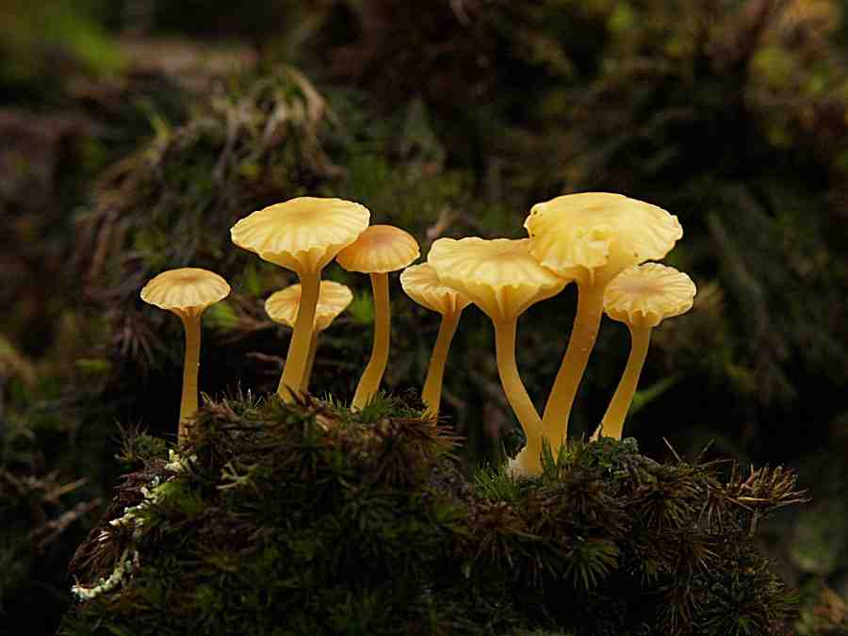
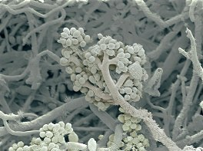
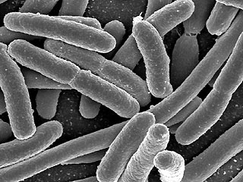
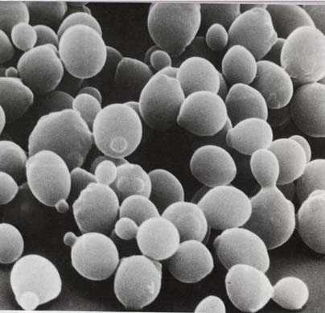
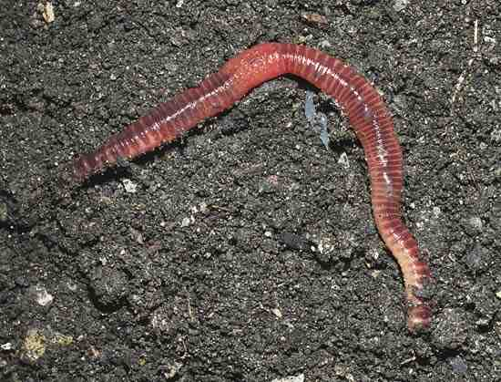
FUNGI
MOLD
DECOMPOSING BACTERIA
YEAST
EARTHWORM

Comparing Organisms

 | PLANTS | ANIMALS | DECOMPOSERS
What can be “food” for these living things and where do they get it?
What materials do these organisms take inside their cells?

How does this organisms change materials?

How does this organisms change energy?

Activity 6: Matter and Energy in Ecosystems

Overview
Introduction question ~5 minutes
What Do Food Chains Tell Us? ~30 minutes
Ecosystem Chart: Matter and Energy ~15 minutes

Total Estimated time: 50 + minutes

Materials
Ecosystem Chart
5 color markers
Student copies of What do Food Chains Tell Us?
Process Tool for Plant growth, Animal Growth, and Animal Movement

Procedures

- Look at the ecosystem chart. Pose the question, “Think of the prey (primary consumer) eaten by a predator (or secondary consumer). What do you think happens to the matter of the prey when it is eaten? (Matter either becomes part of the predator’s body as it grows, or it is used by the cells and given off as gases). Remind students of what they know about how animals grow and move? How do they use their food to help them grow and move?

Process Tool for Food Chains

- Pass out What Do Food Chains Tell Us?

- Read the directions to the students. As a class complete the first process tool together. This process tool is about plants/grass growing. Students should know something about plant growth although they may need scaffolding to figure out how they change matter and energy. Plants convert light energy to chemical energy. They convert carbon dioxide and water into sugar and oxygen.

- Then use the process tool to build simple food chains to show changes in matter and energy when a rabbit eats the grass. Consider doing this process tool together. Remind students that all organisms (even plants and decomposers) use some of the food they make or eat, and give off gases as waste. But some of the food is stored and used to grow. This is the part of the materials and energy that are made available to the next organisms in the food chain.

- Have students complete the last step where the wolf eats the rabbit on their own. Then use the process tool to discuss what kids put on their diagrams.

- Again point out that only some of the original chemical energy in the grass that was eaten by the rabbit was made available to the wolf because the rabbit already used some of the food.

Matter and Energy on Ecosystem Chart
- If time, go back to the ecosystem chart, and review the story of matter flow in the ecosystem. Carbon dioxide and water used by the producers as raw materials to make food and incorporate minerals as they grow. The producers and consumers return carbon dioxide and water to the environment when they use food. If needed, extend a matter arrow to the decomposer box and back into the environment. Place a ‘minerals’ label near the arrow. If not already present, add arrows from minerals to the producers box to show the cycle. Point out that the materials that flow between organisms are food in the form of different body structures and this has chemical energy.
- Review the story of energy flow through the ecosystem, this time adding the decomposers. Extend the color-coded arrows to the decomposer box. Emphasize the idea that sunlight is the energy source for the producers, while the food from the next lower level provides chemical energy for all consumers and decomposers. Ask students what is the energy source for decomposers: it is the chemical energy found in dead plants and animals. Ultimately the energy leaves the ecosystem as motion and heat (actually mainly heat).

Ecosystem Chart Color Key

Materials/Matter

Food (organic carbon in organisms)

Carbon dioxide and water

Energy

Light Energy

Chemical Energy

Heat

Note: You can use a separate color for motion energy if needed.
Name: ________________________________________ Date: _____________

What Do Food Chains Tell Us?

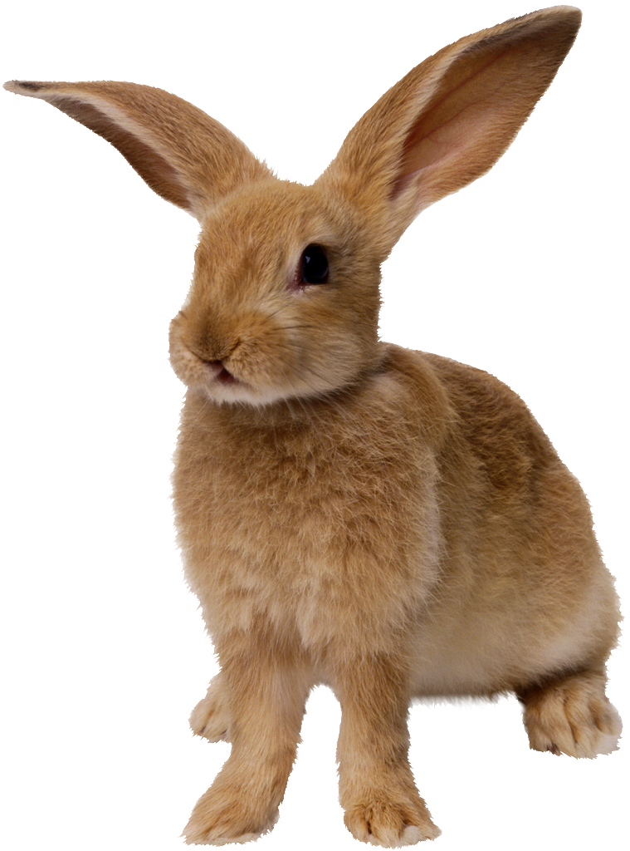
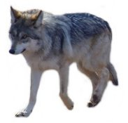
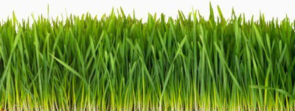
The food chain shows a rabbit eating grass, and a wolf
eating a rabbit. What do the arrows tell us about the
matter and energy that moves between the organisms?

Practice: First, think about the grass. How does the grass change matter and energy? Use the process tool to show how grass makes its food.

Grass Growing

Energy
Energy

Matter
Matter

Grass will use some of the food it makes to keep its cells functioning, and when it uses this food, it gives off gases into the air. But a lot of the materials plants make stay stored in their body structure, like blades of grass, or branches on trees. This stored material is what becomes food for the rabbit in the food chain. On the next page, show how matter and energy change when the rabbit eats the grass.
Remember there are two things that can happen to food when the rabbit eats grass. The food can be used to grow or the food can be used to move.
Rabbit Eats Grass and Uses it to Grow
Chemical Energy in Grass
Grass (solid)
Air/oxygen (gas)
Rabbit Eats Grass and Uses it to Move
Matter
Matter
Energy
Energy
Energy
Matter

The food the rabbit eats and uses to move will become part of the air in the atmosphere, so the wolf is not able to have those materials. When the wolf eats the rabbit, it only gets the materials the rabbit stored in its body to grow. On the next page, use the process tool to show what happens to matter and energy when the wolf eats the rabbit.

Remember there are two things that can happen to food when the wolf eats the rabbit. The food can be used to grow or the food can be used to move.

Matter
Matter
Energy
Energy
Energy
Matter
Wolf Eats Rabbit and Uses it to Grow
Chemical Energy in Grass
Rabbit body structure (solid)
Air/oxygen (gas)
Wolf Eats Rabbit and Uses it to Move

* Adapted from the SCIIS Communities unit, Chapter 16 Producers, Consumers and Decomposers. Pp. 80-82.

